John Michael Go
Career Entry Level Java Programming
Date: Jan. 22, 2013

DAY 8

Program Name: Array2

Objective: Program that prints the values of an array.

Algorithm:

1. Program outputs the values of an array.

Flowchart:
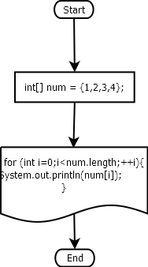

Pseudocode:

public class Array2 {

public static void main(String[] args) {

int[] num = {1,2,3,4};
for (int i=0;i<num.length;++i)
{
System.out.println(num[i]);
}
}

}

Screenshots:

